**Launching of the SPARK Africa initiative**

**Report on the SPARK Africa Bootcamp and Conference**

**Zimbabwe Victoria Falls – 27-31 March 2023**

*Derick Munkombwe, Alice Mutambiranwa and Collen Masimirembwa*

**1.0 Background**

The SPARK at Stanford translational research program established at Stanford University in USA partnered with the African Institute of Biomedical Science and Technology (AiBST) in Zimbabwe to develop the SPARK Africa program to help respond to health challenges faced across the continent. While an increasing number of researchers at African institutions have acquired a wealth of expertise in biomedical research, there still remains a lack of resources, funding and collaboration, as well as a lack of an established pharmaceutical or biotechnology industry, to convert discoveries into clinical solutions for African populations. We therefore, for the first time in Africa, organized a translational research bootcamp and conference to bring together scientists from across African universities and research institutes for training and collaboration using the SPARK translational research model. Through this event, SPARK Africa aimed to help build a local ecosystem of African scientists to directly address the health needs of the continent. The bootcamp and conference also aimed to create opportunities for education, interaction and collaboration to enable and empower local researchers with tools and approaches towards the local discovery of drugs, vaccines, diagnostics and medical devices.

**2.0 Bootcamp and Conference**

**2.1 Call for Participation and Applicants**

A call for participants to the Bootcamp and Conference was made on 1st February 2023 and submission deadline for applications set to 1st March 2023. Scientists from 15 countries applied. The countries included Benin, Burkina Faso, Cameroon, Ghana, Kenya, Mozambique, Nigeria, Rwanda, South Africa, Tanzania, Tunisia, Uganda, UK, Zambia and Zimbabwe. Sixty-five (65) scientists applied. Of the 65 scientists, majority; [47 (74%)] were males, [27 (42%)] had small research group of less than 5 team members, [37 (57%)] were researching on therapeutic products, [27 (42%)] research work experience ranged from 2 to 5 years, [29 (45%)] their research budget was less than $10,000 USD, [29 (45%)] source of research funds was from international agencies, [57 (88%) had research products not patented, [30 (46%)] main challenge was access to research funds and [63 (97%)] requested for financial support to attend the APARK Africa Bootcamp and Conference (Table 1).

**Table 1: Demographic characteristics of Bootcamp and Conference Applicants (n=65)**

|  |  |  |
| --- | --- | --- |
| **Variable** | | **N (%)** |
| Sex |  |  |
|  | Female | 17 (26) |
|  | Male | 47 (74) |
| Size of Group of applicant |  |  |
|  | <5 | 27 (42) |
|  | 5-10 | 23 (35) |
|  | 11-20 | 7 (11) |
|  | 21-30 | 2 (3) |
|  | >30 | 6 (9) |
| Product Category |  |  |
|  | Therapeutics | 37 (57) |
|  | Diagnostics | 14 (21) |
|  | Vaccine | 3 (4) |
|  | Medical Device | 12 (18) |
| Research Working Years |  |  |
|  | <2 | 19 (29) |
|  | 2-5 | 27 (42) |
|  | 6-10 | 10 (15) |
|  | >10 | 9 (14) |
| Research Budget Used (USD) |  |  |
|  | <10K | 29 (45) |
|  | 10-100K | 16 (25) |
|  | 100-500K | 14 (21) |
|  | 500K-1Million | 1 (2) |
|  | >1Million | 5 (7) |
| Source of Funding |  |  |
|  | Government | 16 (25) |
|  | International Agencies | 29 (45) |
|  | Private Funders | 20 (30) |
| IP Status |  |  |
|  | Patented | 8 (12) |
|  | Not Patented | 57 (88) |
| Technology Transfer office |  |  |
|  | Available | 28 (43) |
|  | Not Available | 37 (57) |
| Research Challenges |  |  |
|  | Funding | 30 (46) |
|  | Technology | 21 (33) |
|  | Partnerships | 9 (14) |
|  | Commercialization | 5 (7) |
| African Region |  |  |
|  | North Africa | 4 (6) |
|  | Central Africa | 37 (57) |
|  | East Africa | 8 (12) |
|  | West Africa | 10 (16) |
|  | Southern Africa | 6 (9) |
| Sponsorship |  |  |
|  | Requested for Support | 63 (97) |
|  | Did not Request for Support | 2 (3) |

Data in this table does not include the Minister and his entourage

**2.2 Selected Applicants for the Bootcamp and Conference**

Out of a total of 65 scientists who applied, only 32 were selected to attend the Bootcamp training meeting. Of the 32 selected, 30 (94%) received sponsorship for the fellowship while 2 (6%) participants paid for themselves. Gender balance was taken into consideration in the selection process with female gender at 47% as compared to 26% at the time of application. The rest of the variables in those selected were statistically similar to those who applied (Table 2).

**Table 2: Characteristics of Bootcamp and Conference Selected Participants (n=32)**

|  |  |  |
| --- | --- | --- |
| **Variable** | | **n (%)** |
| Sex |  |  |
|  | Female | 15 (47) |
|  | Male | 17 (53) |
| Product Category |  |  |
|  | Therapeutics | 13 (41) |
|  | Diagnostics | 8 (25) |
|  | Vaccine | 3 (9) |
|  | Medical Device | 8 (25) |
| Research Budget Used (USD) |  |  |
|  | <10K | 13 (41) |
|  | 10-100K | 8 (25) |
|  | 100-500K | 6 (19) |
|  | 500K-1Million | 1 (3) |
|  | >1Million | 4 (12) |
| Source of Funding |  |  |
|  | Government | 6 (19) |
|  | International Agencies | 17 (53) |
|  | Private Funders | 9 (28) |
| IP Status |  |  |
|  | Patented | 7 (22) |
|  | Not Patented | 25 (78) |
| Research Challenges |  |  |
|  | Funding | 18 (56) |
|  | Technology | 11 (35) |
|  | Partnerships | 2 (6) |
|  | Commercialization | 1 (3) |
| African Region |  |  |
|  | North Africa | 4 (13) |
|  | Central Africa | 14 (44) |
|  | East Africa | 6 (19) |
|  | West Africa | 4 (12) |
|  | Southern Africa | 4 (12) |
| Sponsorship |  |  |
|  | Received support | 30 (94) |
|  | Self-sponsored | 2 (6) |

Data in this table does not include the Minister and his entourage



**Figure 1: Source of Funding for All Applicants and Selected Applicants.** The largest percentage of funding received by scientists came from international agencies. African governments were lowest in funding research.



**Figure 2: Previous Size of Budget Received by Scientists who attended SPARK Africa Bootcamp.** The greatest number of scientists received less than $10,000 USD research funds for their research projects. Research in general seems to be underfunded in Africa.

**3.0 Agenda and activities for the Bootcamp and Conference**

**3.1 Bootcamp – unlocking the SPARK Model**

During the 3-day Bootcamp training from 27th to 29th March 2023, drug discovery topics and activities were covered.

**Day 1:** Welcome remarks were given by the AiBST CEO and all the participants present introduced themselves. There were scientists from Benin, Burkina Faso, Cameroon, Ghana, Kenya, Mozambique, Rwanda, South Africa, Tanzania, Tunisia, Uganda, UK, Zambia and Zimbabwe. The program overview was outlined thereafter. Lectures delivered included, 1) Starting With the End in Mind - Clinical Need Assessment & Target Product Profile Development, 2) Translating a Therapeutic Discovery and 3) Understanding the Problem - Chronic Ear Drum Perforations Case Study in Product Discovery. A workshop was conducted on Design Thinking Approach to Translational Medicine. There was a panel discussion where drug development experts discussed Developing Target Product Profile (TPP) and Project Selection. This was followed by developing a Target Product Profile by participants who worked in groups of 5 to 7 people.

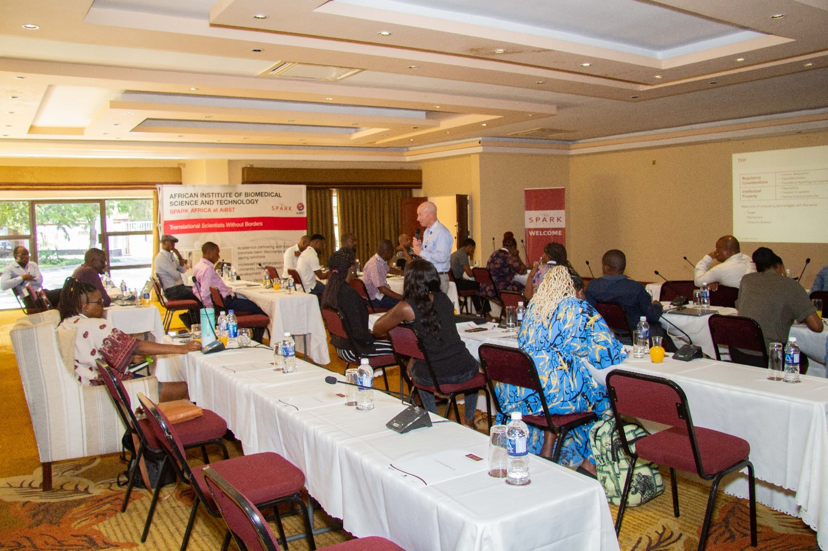

**Day 2:** There were lectures on; 1) Diagnostic & Biomarker Development, 2) Pharmacogenomics-Preclinical & Clinical Considerations, 3) Clinical Trial Design and 4) Developing a Treatment - Chronic Ear Drum Perforations Case Study in Product Development. In a panel discussion for this day, a team of experts discussed Challenges of Product Development in Academia and Africa in particular. The main challenge identified was lack of sufficient research funds to de-risk research work in Africa. Currently, most scientists in Africa have small budgets ranging from $10,000 USD to $100,000 USD not good enough to undertake drug discovery research. It was proposed that African governments and philanthropists need to be approached for possible discussion about increasing research funds and support towards basic as well as translational research. Then participants worked in groups to pitch the target product profiles they developed on day 1.

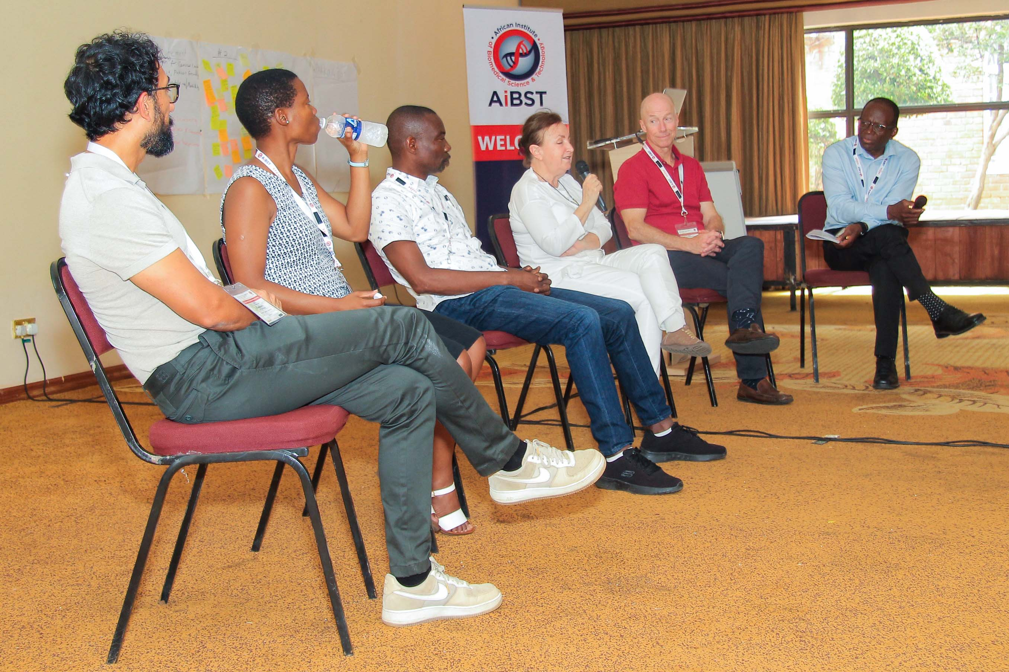

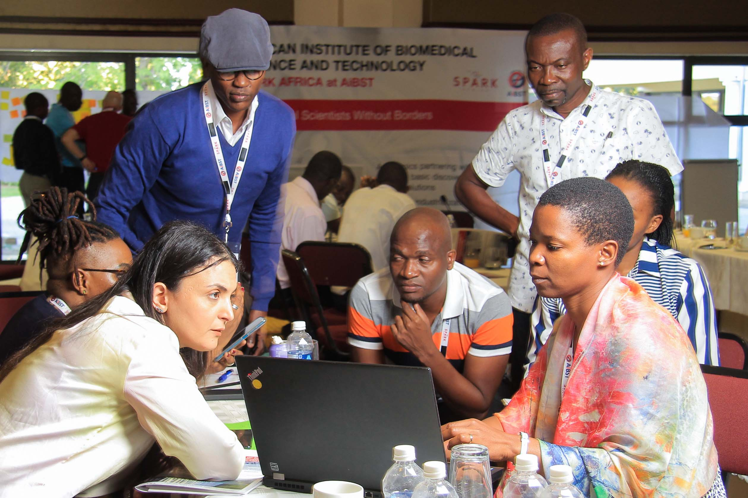

**Day 3:** Started with lessons learned in drug development process where potential challenges as well as past achievements were highlighted. Two lectures were given on day 3; 1) Delivering an Effective Pitch to Potential Investors and 2) Delivering a Solution -Chronic Ear Drum Perforations Case Study in Product Delivery. Thereafter a panel discussion on Challenges of Product Commercialization was conducted. The main pointer that came out from this discussion panel was that actually African governments are ready to fund product commercialization if the developed product(s) add value to people’s lives in Africa. Scientists were reminded that they have a responsibility to meet healthcare needs of their communities. In the afternoon, participants in groups had time to do power point presentations on their Target Product Profiles they developed and pitched during the training in day-1 and day-2 to all participants in order to receive feedback. Later in the afternoon, Bootcamp participants had a tourism event which included boat cruise and the Boma entertainment.

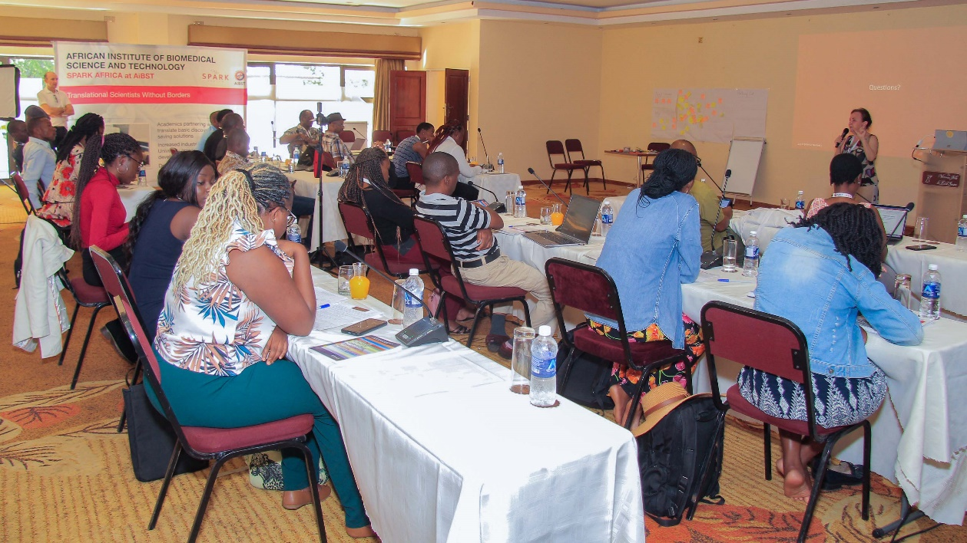

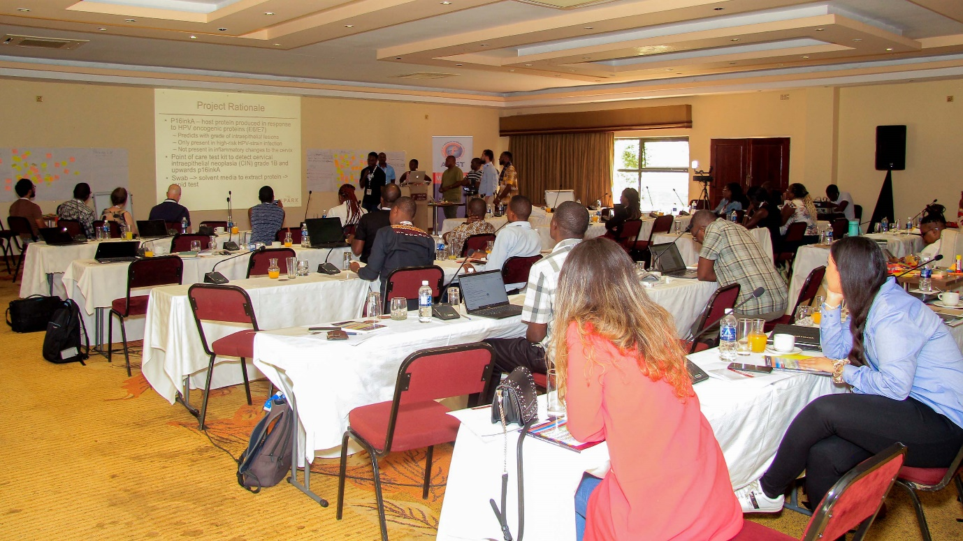

**3.2Conference – Engaging Stakeholders**

During the 2-day Conference with stakeholders from 30th to 31st March 2023, drug discovery topics and funding opportunity options were discussed.

**First day of the Conference:** The initial lecture on how education 5.0 can drive industrialization in Zimbabwe was presented by the Zimbabwe Minister of Higher and Tertiary Education. This was followed by a lecture on the SPARK at Stanford Model for academia that was given by trainers from Stanford University. Then there was a panel discussion in which the Minister participated. The discussion was about establishing an academic-based pharmaceutical ecosystem in Africa. It was suggested that for Africa to establish an ecosystem, it needed to harness the already available research capacity from among the African scientists both at home and abroad and at the same time build capacity in young scientists. Further it was observed that creation of SPARK Africa was timely to bring about much needed collaborations among African research institutions. The time to identify product development champions from south, north, west, east and central African could not be any other time than now. Creation of SPARK Africa was unanimously agreed since all the African regions were present at the conference. Way forward suggested was to register SPARK Africa officially and support its organic growth by starting with the end in mind. In the afternoon there was a lecture titled; From Developing Antimalarial Tetraoxanes to Establishing a Drug Discovery Hub in Ghana. On this day, the Minister had chance to listen to one of the TPP that was developed and pitched during the training by participants.

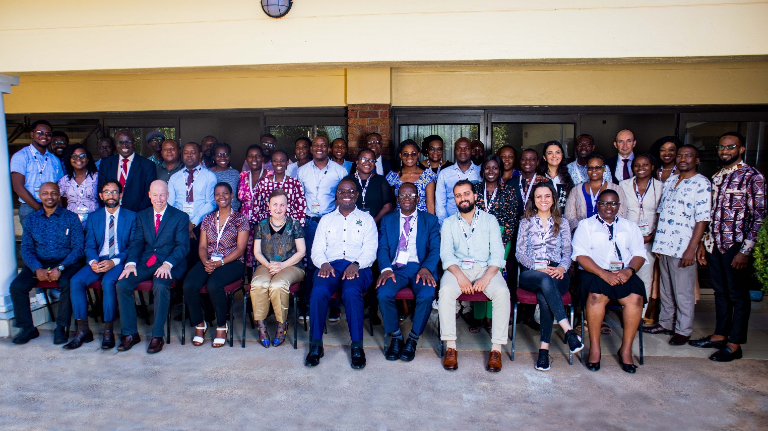

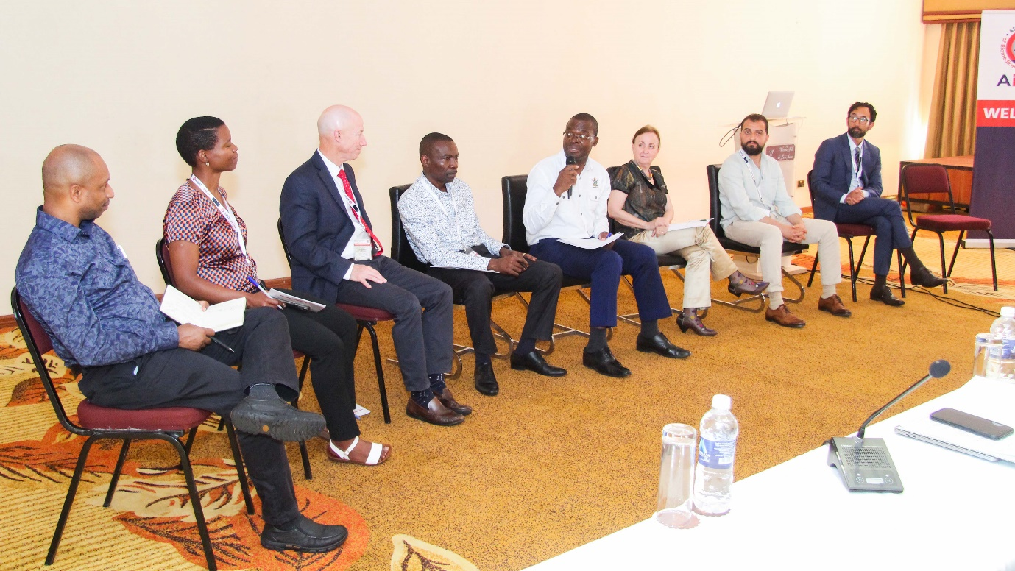

**Second day of the Conference:** The Zimbabwe Minister of Higher and Tertiary Education recognised and promoted efforts of scientists across Africa by making $30,000 USD available as seed fund for translational research in Africa. Three projects to be supported with $10,000 USD each. The Minister emphasised that the seed fund was meant to support growth and de-risking of research projects in Africa. It was emphasized that there was need to create an ecosystem in Africa and to look at the world as one big ecosystem if progress is to be made in as far as product development is concerned in Africa. This was followed by a presentation on Building a Venture Capital Ecosystem in Africa. The presentation demonstrated that Africa is capable of mobilizing research funds to support translational research. A presentation on Designing with the End in Mind-Design and Implementation of a low-cost, High-Impact Solution underscored the importance of identifying venture capitalists in Africa. The African Union’s Vision for Drug Discovery in Africa which is part of Agenda 2063 was presented. The implementation plan summary for SPARK Africa was the presented and the concluding remarks were given in closing the Bootcamp and Conference.

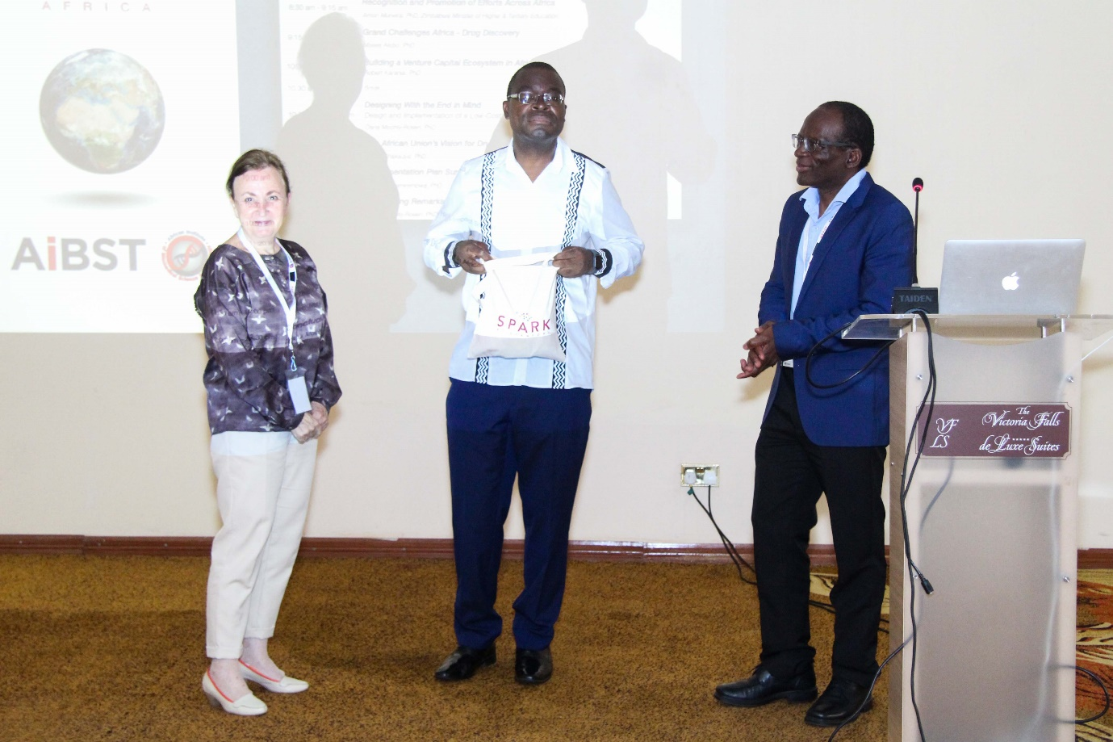

**4.0 SPARK Africa Meeting Outcomes**

The meeting unanimously agreed to create a research program in Africa called SPARK Africa. SPARK Africa is a network of translational scientists designed to realize product development and product commercialisation for healthcare systems across African continent and beyond. The proposed and adopted vision, mission and objectives of SPARK Africa are as follows:

**4.1 Vision**

To enable academicians todevelop & commercialise pharmaceutics, vaccines, diagnostics, and other life science products in Africa, by Africans, that address Africa’s unmet health needs.

**4.2 Mission**

To establish an African network of scientists in product development with the aim to support translational projects with scientific and technical knowhow, access to specialized resources, and seed funding to de-risk project the product development and commercialisation value chain.

**4.3 Objectives**

**Objective 1**- SPARK Africa registration and management team

**Activities**:

1. To host SPARK Africa at AiBST at formation stage and support it with the Projects Manager.
2. To establish a voluntary management committee to run the affairs of SPARK Africa
3. To establish a flexible governance framework that promotes collaboration, communications, and sharing of knowledge and resources.

**Objective 2**- Membership and alumni networking

**Activities**

1. To establish a network of SPARK Scholars (those who will have attended at least one of the SPARK bootcamps on product development)
2. To maintain membership scheme by attending SPARK training)

**Objective 3**: Annual meetings, bootcamp and conferences

**Activities**

1. Conduct a general assembly (even virtual, each year) of the members of the organizing committee or with other members to establish the annual action plan.
2. To conduct an annual SPARK Africa event
3. To host SPARK Global every several years
4. To provide education in translational sciences, product development, entrepreneurship etc, in bootcamps and in ongoing training throughout the year, using the SPARK educational model.

**Objective 4**: Procurement of funds and future collaborations…

**Activities**

1. To identify potential funders of health innovation and product development in Africa in the form of Venture Capitalist, philanthropists, and government
2. To register SPARK Africa as a stand-alone not-for-profit-entity

**Objective 5**: Establishment of future collaborations…

1. To identify/map scientists and innovators with a track record of product development in the health sector with a view to foster collaboration and to invite some to an Advisory/Mentorship Committee that can be accessed by other SPARK participants
2. To identify/map centres of excellence with infrastructure and technologies important for product development in home countries of SPARK Africa scientists with a view to explore mechanisms for shared access to such resources.

**Objective 6**: Provide support to Spark Africa members only.

**Activities**

1. To help de-risk projects by providing seed funding to address key steps that unlock value of projects and make them attractive for VC investing.

**Objective 7**: Integrate with the continental research and innovation ecosystem

**Activities**

1. To provide regulatory science support to key stakeholders such as AMA and Africa CDC for a regulatory framework for product registration that enables product development and commercialisation
2. To provide  integrated systems-thinking approach support to AUDA/NEPAD, AfDB, RECs and national govts in establishing a knowledge-base integrated biopharma industry based on locally developed health products.
3. To establish working groups around key requirements for successful product development such as IP & technology transfer, specialised infrastructure, disease model experts, regulatory requirements and funding/business models.

**Objective 8:** Multiplication of SPARK Africa centres in other African countries…

1. To assist institutes and countries to establish SPARK programs under the SPARK Africa brand and operational framework. That is, a SPARK program must meet certain minimum organisational and operational requirements. They will operate as affiliates of SPARK Africa.
2. To synergistically partner with other complementary initiatives that are promoting product development in Africa.

5.0 Conclusion

Collaboration between SPARK at Stanford in USA and SPARK at African Institute of Biomedical Science and Technology (AiBST) in Zimbabwe successfully established SPARK Africa via the translational research Bootcamp & Conference held in March 2023. The conference that brought stakeholders together from all parts of Africa was a successful method of creating a network of SPARK Scientists interested in product development and product commercialisation based on SPARK at Stanford model. Collaborative and de-risked projects to be implemented under SPARK Africa are anticipated to promote product development and commercialisation for the research ecosystem and healthcare system on the continent of Africa and beyond. All the research activities will be showcased at the SPARK Africa event every year to be held in different countries on the continent. Finally, data collected and analysed from SPARK Africa Bootcamp and Conference participants, revealed that product development and drug discovery in particular is generally underfunded. Therefore, African governments need to increase support and funding to basic and translational research, if Africa is to achieve Agenda 2063 for the Africa we want.

-END-